GUVI: Zen Class — **Part 1: Find the culprits and nail them — debugging javascript:-**

* fix.html

<!DOCTYPE html>  
 <html>  
 <body>  
 <script>  
 alert( “I’m JavaScript!’);  
 </script>  
 Whats the error in this ?  
 </body>  
 </html>

**Here error** is that one more **‘ in I’m statement .**

**Output :-**

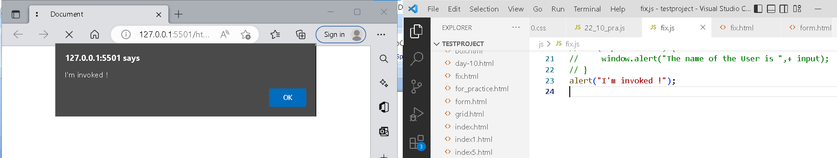

**Explain This code :-**

<!DOCTYPE html>  
<html>  
<body>  
<script src=”script.js”></script>  
</body>  
</html>

**Here html code is link javascript file to our main code.**

**<script src=”Whatever the name of file which you want link**

**And run, it with live server.**

script.js

alert("I'm JavaScript!");  
alert('Hello') // this line is not having semicolon  
alert(`Wor  
 ld`)  
alert(3 +  
1  
+ 2); // this is multiple line code and its working

**Explanation:-**

Here First above code display what things we write in round bracket.

Than second line display world 6.

**Fix below alert Guvi geek.**

fix.html

<!DOCTYPE html>  
<html>  
<body>  
 <script src=”script.js”></script>  
</body>  
</html>

script.js

let admin=9, fname=10.5;   
fname = "Guvi";  
lname = "geek"  
admin = fname+lname;alert( admin ); // "Guvi geek"

Output:-

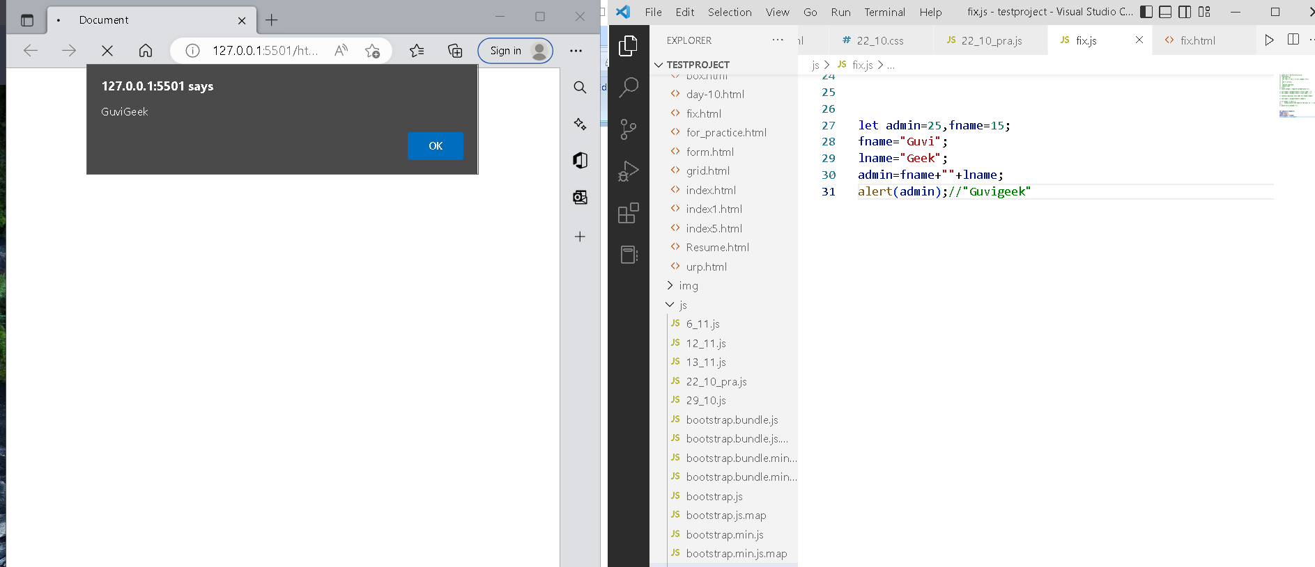

**Fix the below to alert**hello Guvi geek

fix.html

<!DOCTYPE html>  
<html>  
<body>  
 <script src=”script.js”></script>  
</body>  
</html>

script.js

let fname=10.5;lname=2.5   
fname = "Guvi";  
lname = "geek"let name = fname+lname;alert( 'hello ${name}' );

**Output:-**

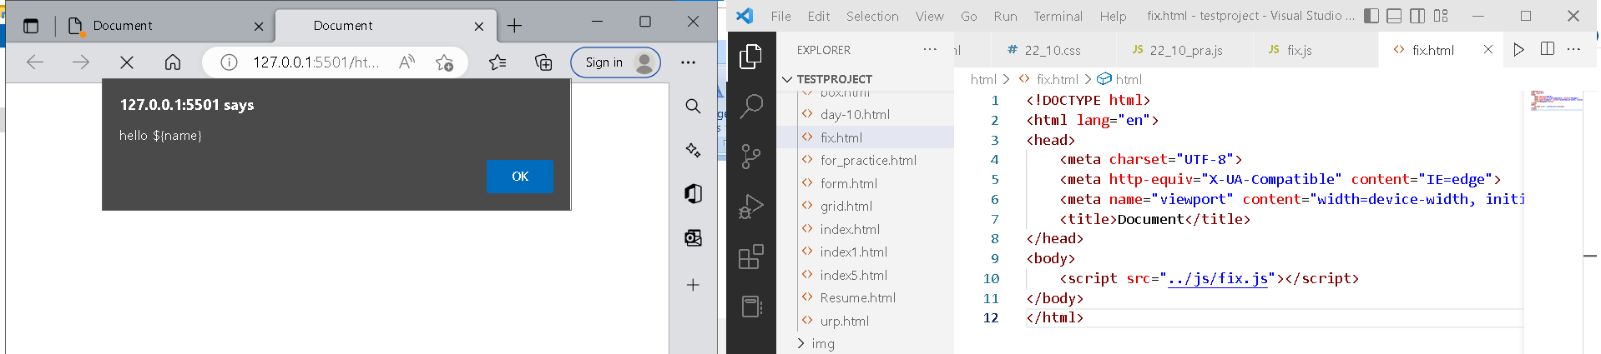

**Fix the below to alert sum of two numbers**

fix.html

<!DOCTYPE html>  
<html>  
<body>  
 <script src=”fix.js”></script>  
</body>  
</html>

script.js

let a = prompt("First number?");  
let b = prompt("Second number?");  
alert(a + b);

Output:-

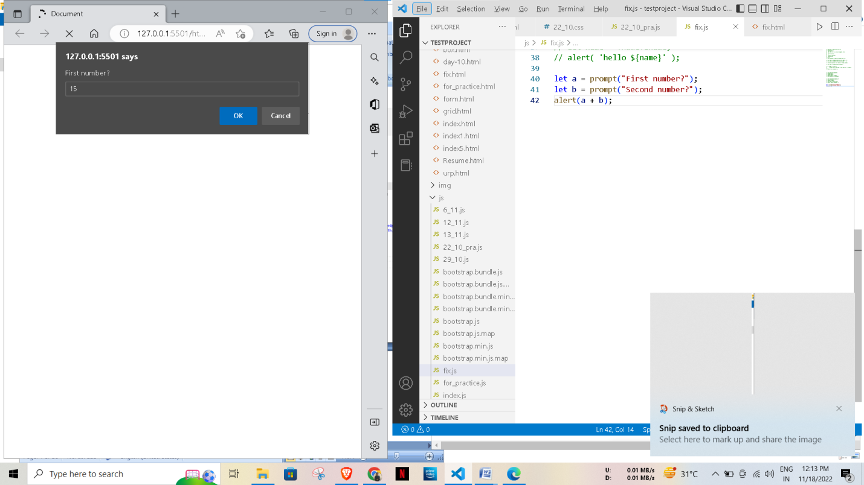

**Explain Why the Code is blasted and how to diffuse it and get “**Diffused**”.**

fix.html

<!DOCTYPE html>  
<html>  
<body>  
 <script src=”script.js”></script>  
</body>  
</html>

script.js

var a = "2" > "12";//Don't touch below this  
if (a) {  
 console.log("Code is Blasted")  
}  
else  
{  
 console.log("Diffused")   
}

Output:-

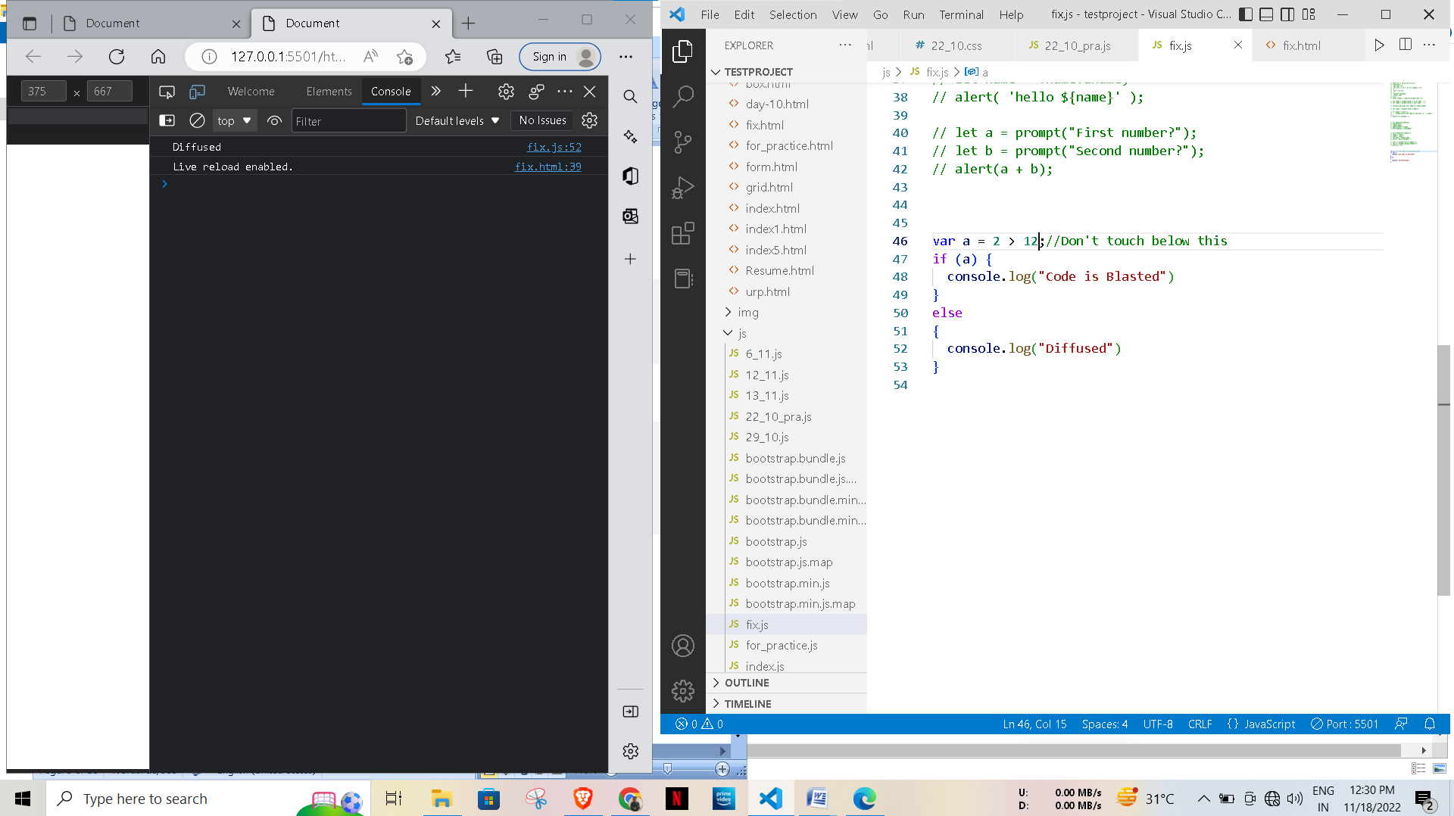

Explanation:-

Here in first line number is between the quotes so that is became string therefore I removed that quotes.

And that is ran perfectly.

**How to get the success in console.**

fix.html

<!DOCTYPE html>  
<html>  
<body>  
 <script src=”fic.js”></script>  
</body>  
</html>

script.js

let a = prompt("Enter a number?");//Don't modify any code below thisif (a) {  
 console.log( 'OMG it works for any number inc 0' );  
}  
else  
{  
 console.log( "Success" );  
}

**How to get the correct score in console.**

fix.html

<!DOCTYPE html>  
<html>  
<body>  
 <script src=”script.js”></script>  
</body>  
</html>

script.js

let value = prompt('How many runs you scored in this ball');  
if (value === 4) {  
 console.log("You hit a Four");  
} else if (value === 6) {  
 console.log("You hit a Six");  
} else {  
 console.log("I couldn't figure out");  
}

**Output:-**

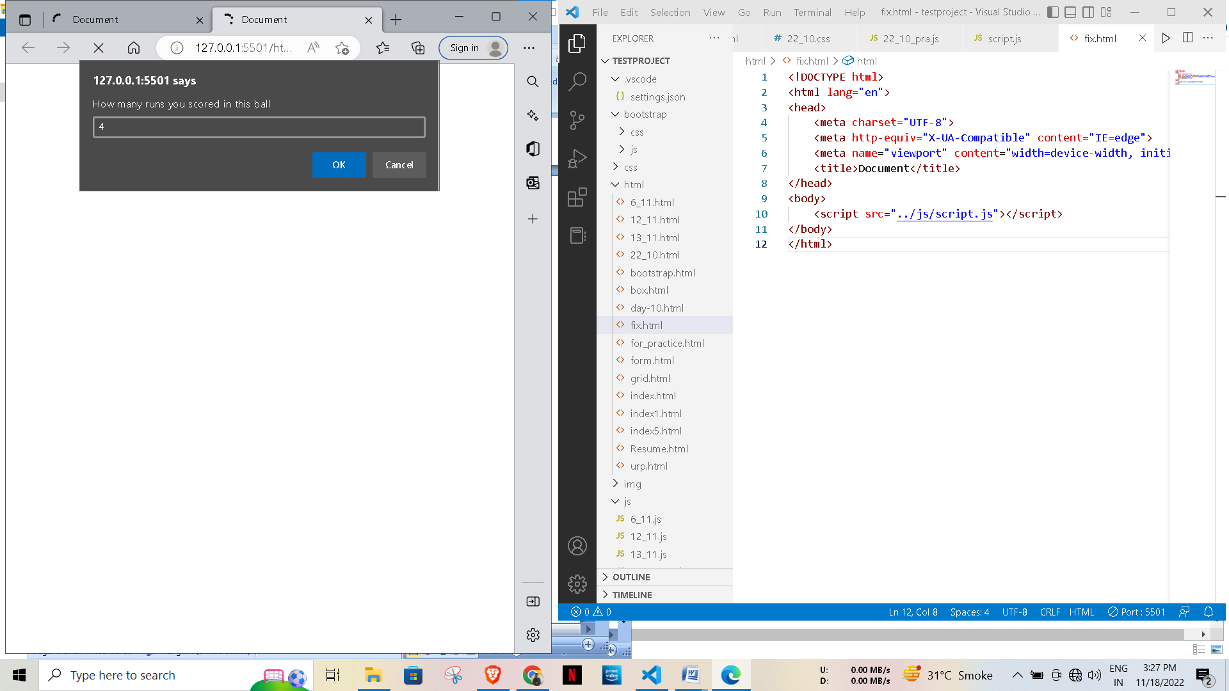

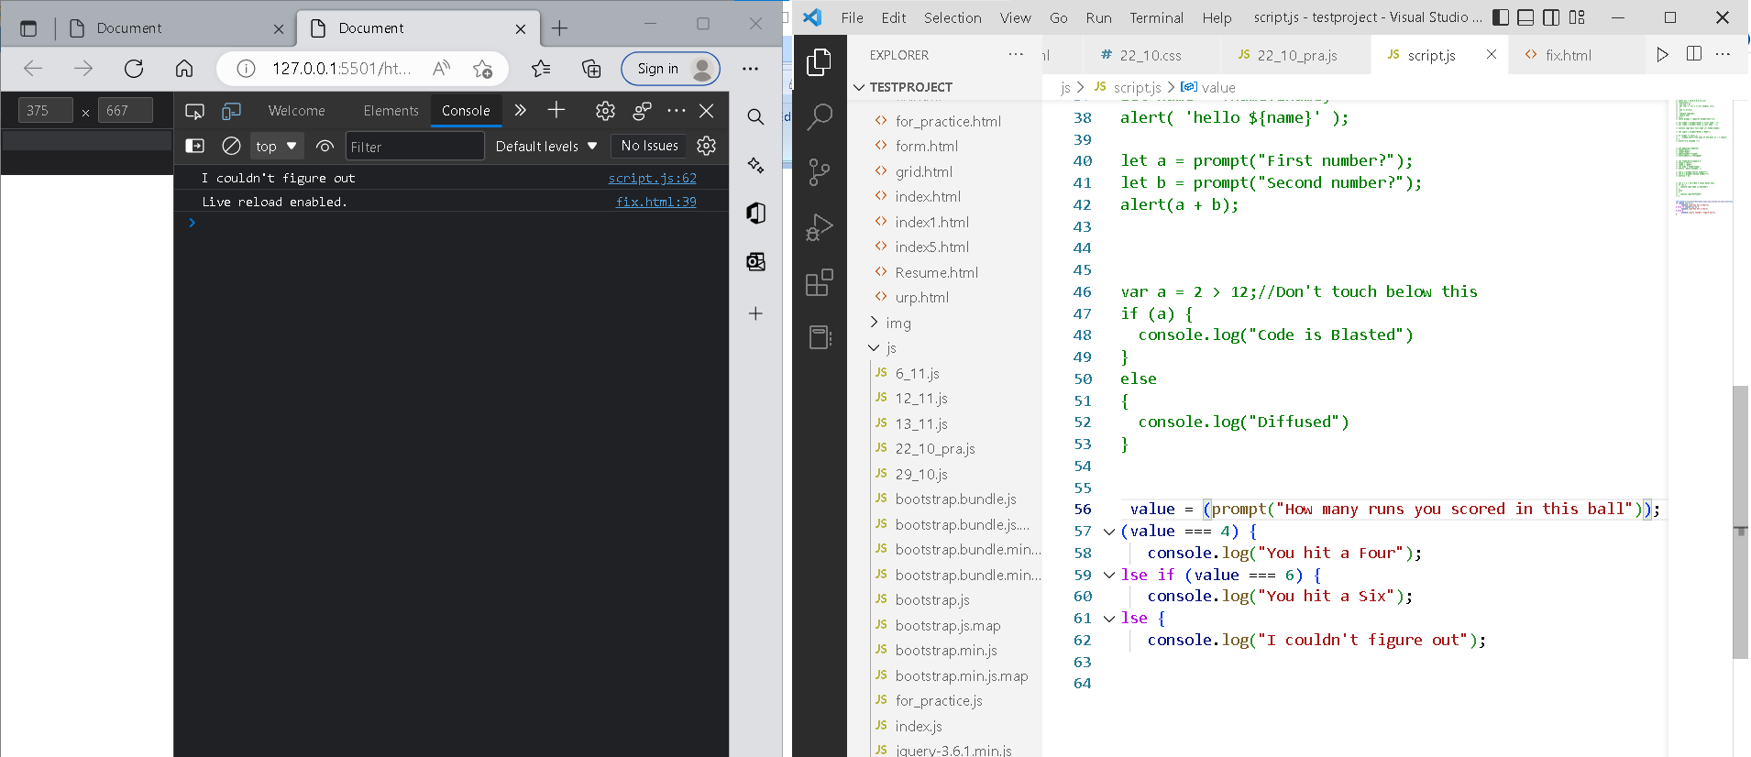

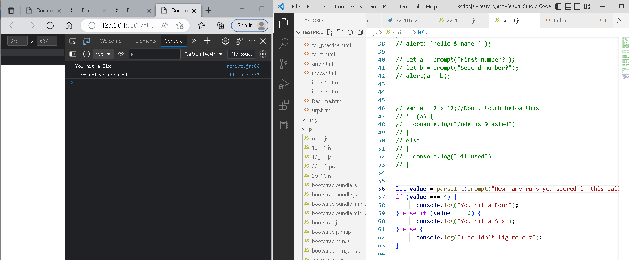

fix.html

<!DOCTYPE html>  
<html>  
<body>  
 <script src=”script.js”></script>  
</body>  
</html>

script.js

let login = 'Employee';  
let message = (login == 'Employee') ?’welcome’ :  
 (login == 'Director') ? 'Greetings' :  
 (login == '') ? 'No login' :  
 '';

console.log(message);

**Output:-** 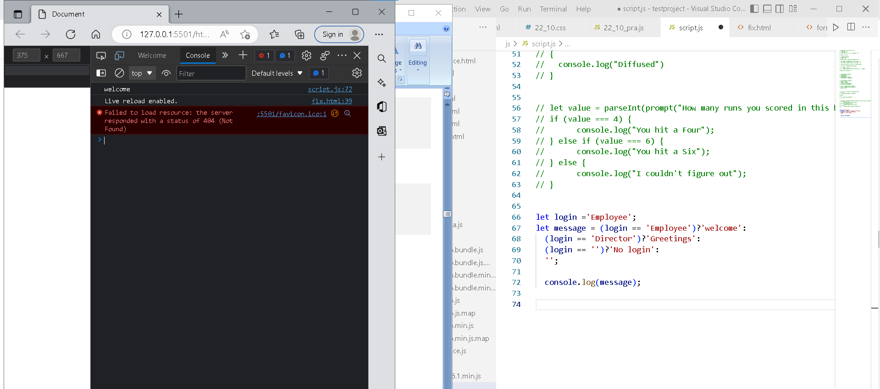

**Fix the code to welcome the boss**

fix.html

<!DOCTYPE html>  
<html>  
<body>  
 <script src=”script.js”></script>  
</body>  
</html>

script.js

// You cant change the value of the msg  
let message;

if (null || 2 || undefined )  
{  
 let message = "welcome boss";  
}  
else  
{  
 let message = "Go away";  
}  
 console.log(message);

**Output:-**

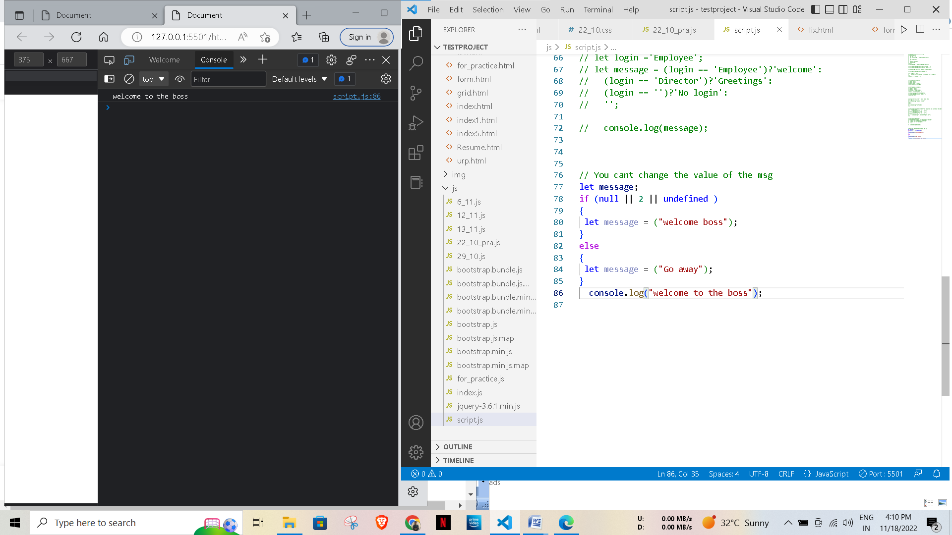 **Fix the code to welcome the boss**

fix.html

<!DOCTYPE html>  
<html>  
<body>  
 <script src=”script.js”></script>  
</body>  
</html>

script.js

let message;  
let lock = 2;//Dont change any code below this if (null || lock || undefined )  
{  
 message = "Go away";  
}  
else  
{  
 message = "welcome";  
}  
 console.log(message);

**Output:-**

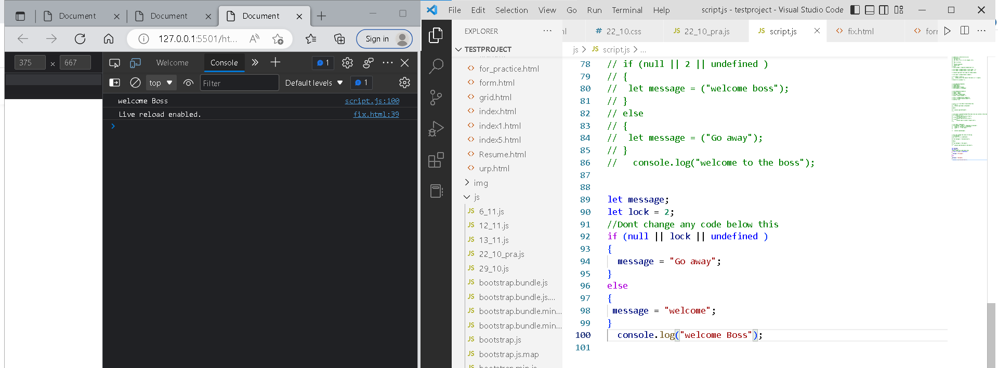

**Change the code to print**

3

2

1

fix.html

<!DOCTYPE html>  
<html>  
<body>  
 <script src=”script.js”></script>  
</body>  
</html>

script.js

//You can change only 2 characterslet i = 3;while (i) {  
 console.log( --i );  
}

**Output:-**

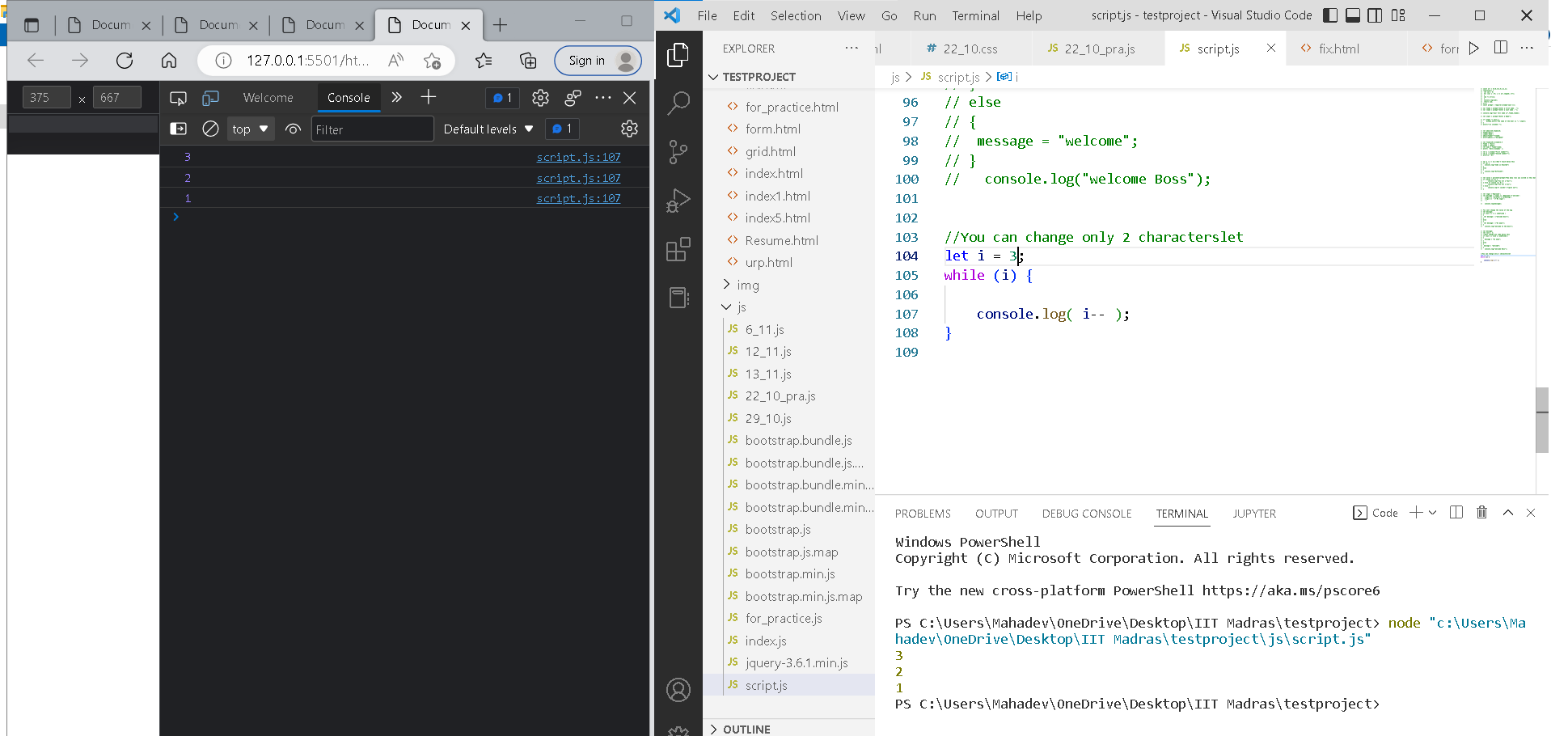

**Change the code to print 1 to 10 in 4 lines**

fix.html

<!DOCTYPE html>  
<html>  
<body>  
 <script src=”script.js”></script>  
</body>  
</html>

script.js

let num = 1  
console.log(num)  
num += 1  
console.log(num)  
num += 1  
console.log(num)  
num += 1  
console.log(num)  
num += 1  
console.log(num)  
num += 1  
console.log(num)  
num += 1  
console.log(num)  
num += 1  
console.log(num)  
num += 1  
console.log(num)  
num += 1  
console.log(num)

**Code :-**

let i=0;

let j=1;

let n=10;

for(i=0;i<=n;i++){

    for(j=0;j<=i;j++){

        console.log(i);

        if(j===4){

            break;

        }

        break;

    }

}

**Change the code to print even numbers**

fix.html

<!DOCTYPE html>  
<html>  
<body>  
 <script src=”script.js”></script>  
</body>  
</html>

script.js

//You are allowed to modify only one character for (let num = 2; num <= 20; num += 1) {  
 console.log(num)  
}

**Output :-**

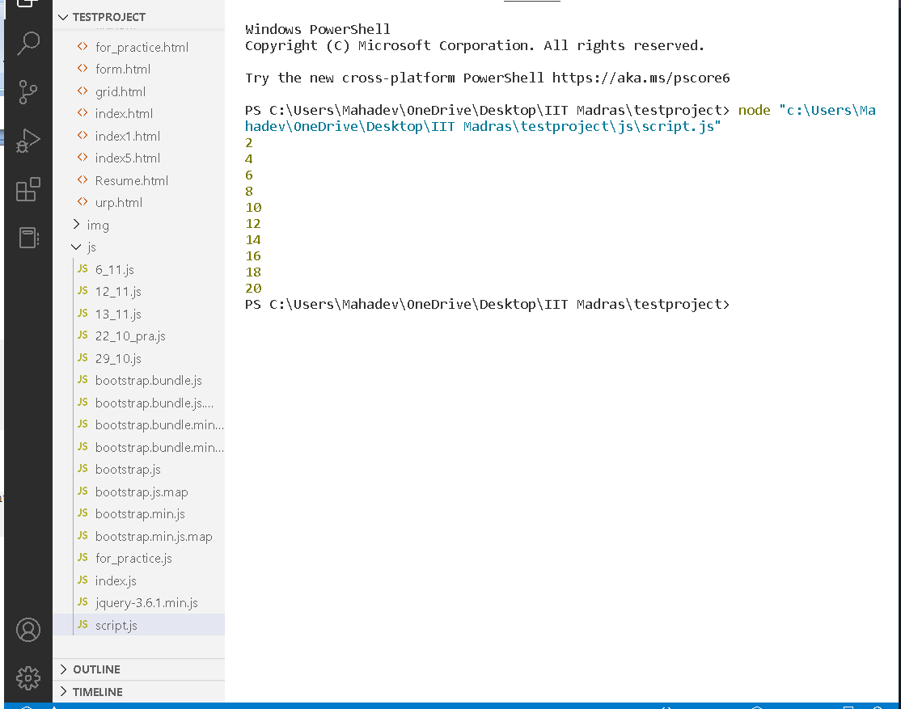

**Change the code to print all the gifts**

fix.html

<!DOCTYPE html>  
<html>  
<body>  
 <script src=”script.js”></script>  
</body>  
</html>

script.js

let gifts = ["teddy bear", "drone", "doll"];for (let i = 0; i < 3; i++) {  
 console.log('Wrapped ${'gifts[i]'} and added a bow!');  
}

**Output:-**

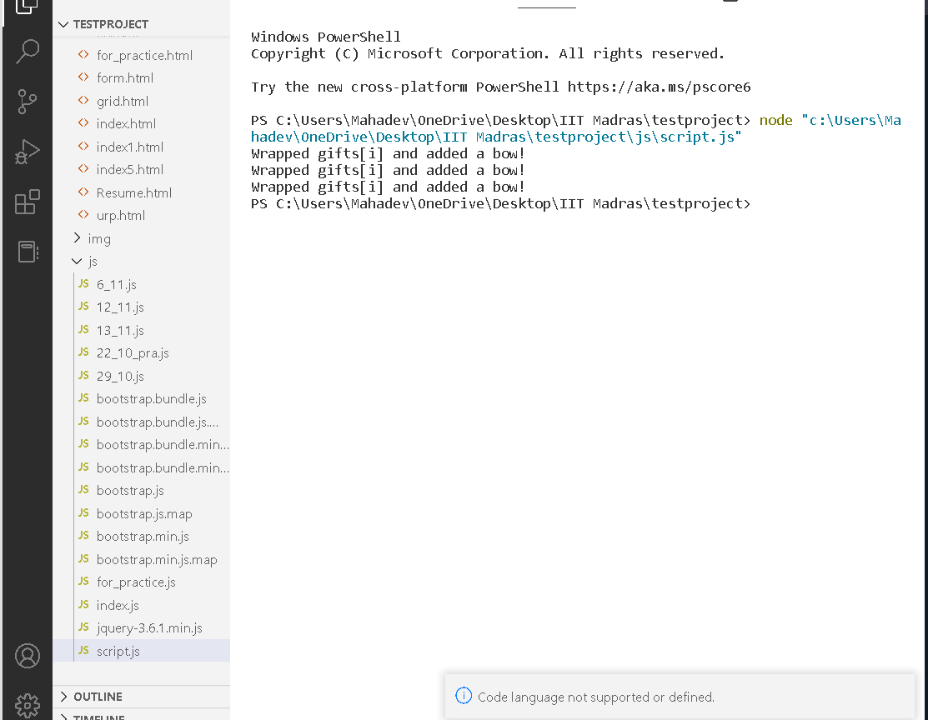

**Fix the code to disarm the bomb.**

fix.html

<!DOCTYPE html>  
<html>  
<body>  
 <script src=”script.js”></script>  
</body>  
</html>

script.js

let countdown = 100;while (countdown > 0) {  
 countdown--;  
 if(countdown == 0)  
 {  
 console.log("bomb triggered");  
 }

}

**Output:-**

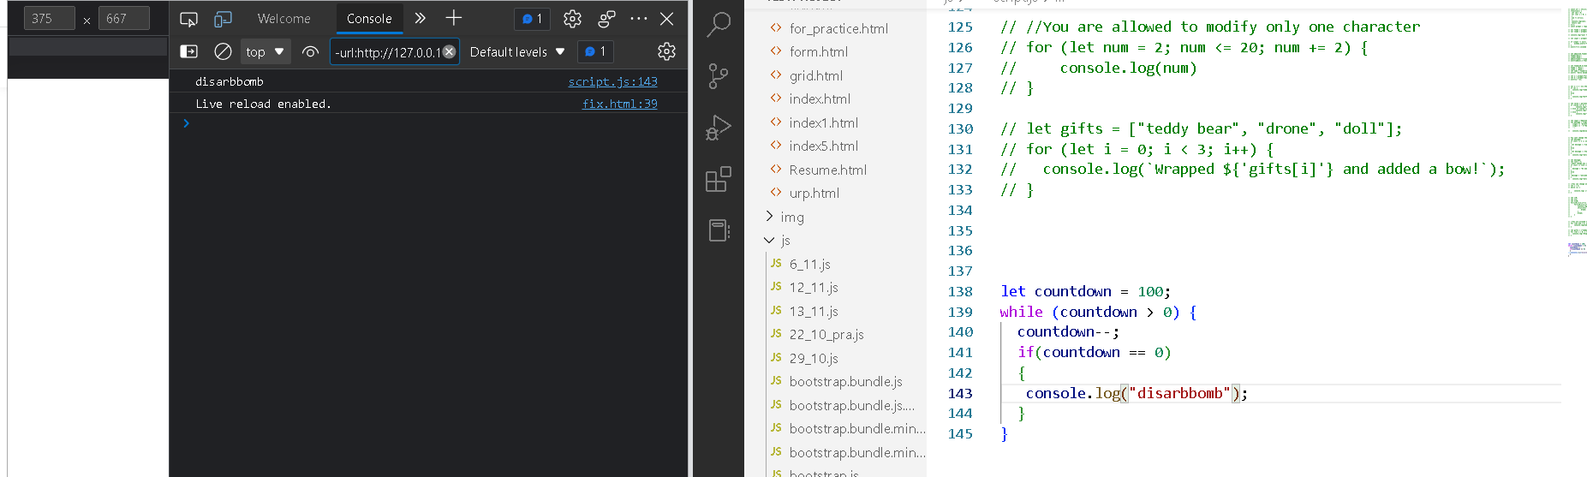

Whats the msg printed and why?

var lemein = “0”;  
var lemeout = 0;  
var msg = “”;

if (lemein) {  
 msg += “hi”;  
 }if (lemeout) {  
 msg += ‘Hello’;  
}console.log(msg);

**Explanation:-**

here if condition for lemein thanprint “hi” and if condition satisfied for lemeout than it gives output “Hello”

This msg will print.

Code:-

var numsArr = [[1, 2, 3, 4, 5],[ 6, 7, 8, 9, 10, 11]];

var str_all=[];

for (var i = 0; i < numsArr.length; i++) {

 var inner_array = numsArr[i];

 for(var j = 0 ; j < inner_array.length;j++ ){

      if(j %2 == 0 )

      {

         str_all.push("even");

       }

       else{

           str_all.push(inner_array[j]);

       }

    }

    }

    console.log(str_all);

**Output:-**

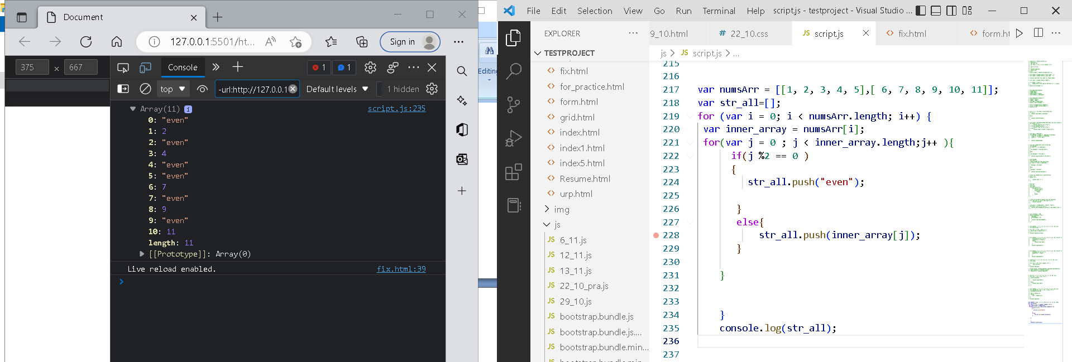

Write a code to print the numbers in the array

**Output**: 1234567891011

var numsArr = [ 1, 2, 3, 4, 5, 6, 7, 8, 9, 10, 11];

var new_string = “”;  
   
for (var i = 1; i < 11; i--) {  
 new_string += numsArr[i]   
}console.log(new_string);

**Output:-**

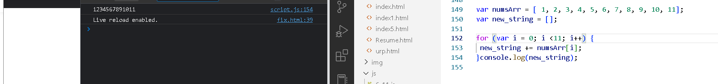

**Output**: 11 10 9 8 7 6 5 4 3 2 1

var new_string = “”;  
   
for (var i = 11; i > 0; i — ) {  
 new_string += numsArr[i] + “ “   
}  
console.log(new_string);

**Output:-**

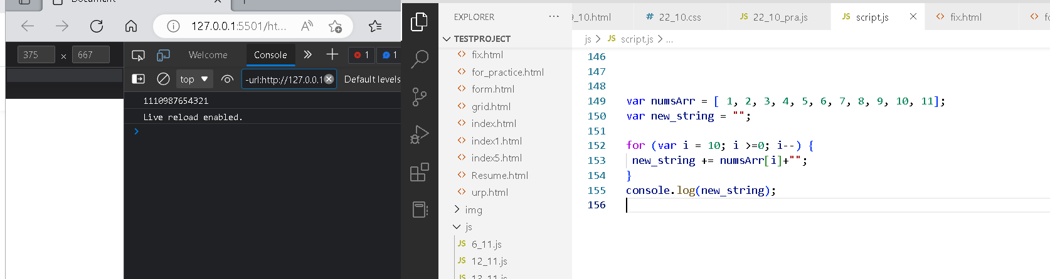

Write a code to replace the array value — If the index is even, replace it with ‘even’.

**Output**: [ “even”, 2, “even”, 4, “even”, 6, “even”, 8, “even”, 10, … ]

var numsArr = [ 1, 2, 3, 4, 5, 6, 7, 8, 9, 10, 11];for (var i = 0; i <=10; i++) {  
 if(numsArr[i] %2 == 0 )  
 {  
 numsArr[i] = even  
 }  
}  
console.log(numsArr);

Write a code to replace the array value — If the index is even, replace it with ‘even’.

**Output**: [ “even”, 2, “even”, 4, “even”, 6, “even”, 8, “even”, 10, … ]

var numsArr = [ 1, 2, 3, 4, 5, 6, 7, 8, 9, 10, 11];for (var i = 0; i <=10; i++) {  
 if(numsArr[i] %2 == 0 )  
 {  
 numsArr[i] = even  
 }  
}  
console.log(numsArr);

**Output:-**

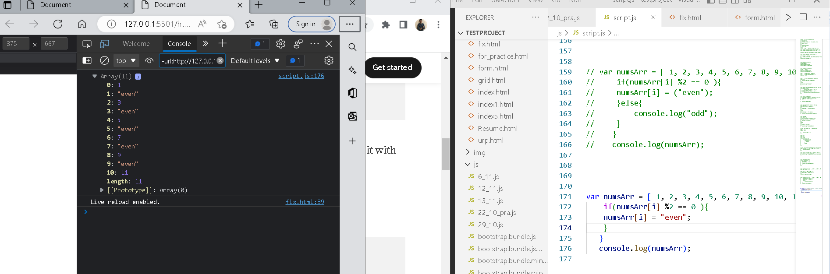

Write a code to add all the numbers in the array

Output: 66

var numsArr = [ 1, 2, 3, 4, 5, 6, 7, 8, 9, 10, 11];

for (var i = 0; i <=10; i++) {  
 var sum;  
 sum += numsArr[i];  
}  
console.log(sum);

**Output:-**

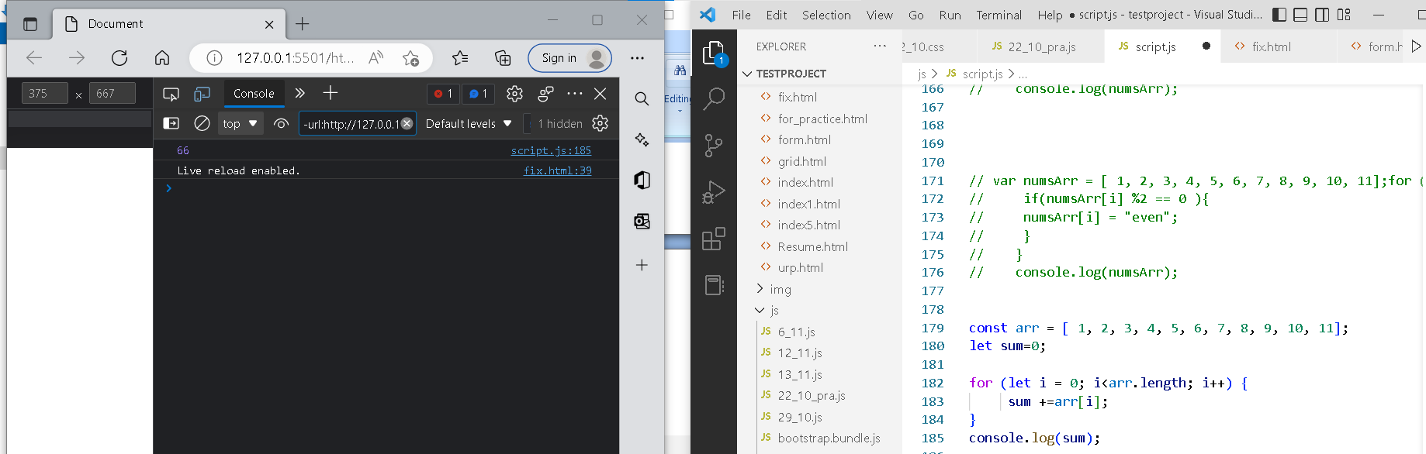

Write a code to add the even numbers only  
**Output**: 30

var numsArr = [ 1, 2, 3, 4, 5, 6, 7, 8, 9, 10, 11];  
var sum=0;for (var i = 0; i <10; i++) {  
 if(numsArr[i]%2==0);  
 sum += numsArr[i]  
}  
console.log(sum);

Write a code to add the even numbers and subract the odd numbers  
**Output**: 94

var numsArr = [ 1, 2, 3, 4, 5, 6, 7, 8, 9, 10, 11];  
var sum=100;for (var i = 0; i <=10; i++) {  
 if(numsArr[i]%2!=0);  
 {  
 sum += numsArr[i]  
 }  
 else  
 {  
 sum -= numsArr[i]  
 }  
}  
console.log(sum);

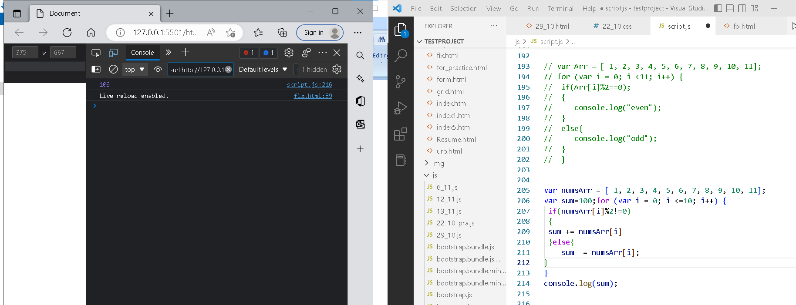

**GUVI: Zen Class — Part 3: Find the culprits and nail them — debugging javascript**

aa = (f,s,t) => {  
 let f,s,t;  
 console.log(f,s,t);  
 if(f>s &&f>t){  
 console.log(f)}  
 else if(s>f && s>t){  
 console.log(s)}  
 else{  
 console.log(t)}  
}

aa(1,2,3);

**Output:-**

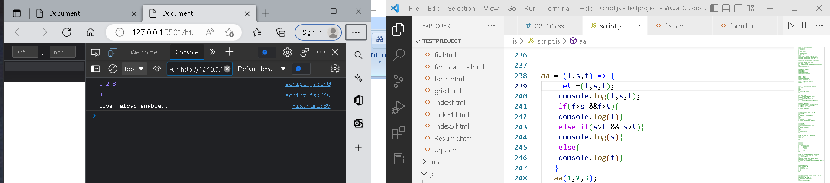

**Fix the code to Sum of the digits present in the number**

Code:

let n = 123;console.log(add(n));function add(n)  
{  
let sum = 10;  
for(var i=0;i<n.length;i++){  
 sum+=n[i]  
 }  
 return sum;  
}

— — — — — — — — — — — — — — — — — — — — — — — — —

**Fix the code to Sum of all numbers using IIFE function**

Code:

const arr = [9,8,5,6,4,3,2,1];(function() {  
 let sum = 0;  
 for (var i = 0; i <= arr.length; i++);{  
 sum += arr[i];  
 }  
 console.log(sum);  
 return sum;  
})();

— — — — — — — — — — — — — — — — — — — — — — — — —

**Fix the code to gen Title caps.**

Code:

var arr = [“guvi”, “geek”, “zen”, “fullstack”];var ano = function(arro) {  
 for (var i = 0; i <= arro.length; i++) {  
 console.log(arro[i][0].toUpperCase() + arro[i].substr(1));  
 }  
}  
ano();

— — — — — — — — — — — — — — — — — — — — — — — — —

**Fix the code to return the Prime numbers**

Code:

const newArray=[1,3,2,5,10];  
const myPrime=newArray.filter(num=>{  
 for(let i=2;i<=num;i++){  
 if(num%i===0)  
 {  
 return true;  
 }  
 }  
 return num===1;  
});  
console.log(myPrime);

— — — — — — — — — — — — — — — — — — — — — — — — —

**Fix the code to sum the number in that array**

Code:

const num = [10, 20, 30, 40,50,60,70,80,90,100]   
const sum = (a, b) =>  
 a + b  
const sum = num.reduce(sum)  
console.log(sum);

— — — — — — — — — — — — — — — — — — — — — — — — —

**Fix the code to rotate an array by k times and return rotated array using IIFE function**

Code:

var arr = [1, 2, 3, 6, 8, 6, 1, 9, 10, 12, 13];  
var k = 3;  
k = arr.length % k;  
(function() {  
 arr = {};  
 out = arr.slice(k + 1, arr.length);  
 var count = out.length;  
 for (var i = 0; i < k + 1; i++) {  
 out[count] = arr[i];  
 count += 1;  
 }  
 console.log(out);})();

— — — — — — — — — — — — — — — — — — — — — — — — —

**Fix the code to gen Title caps.**

Code:

var arr = [“guvi”, “geek”, “zen”, “fullstack”];(function() {  
 for (var i = 0; i <= arr.length; i++) {  
 console.log(arr[0][i].toUpperCase() + arr[i].substr(1));  
 }  
})();

— — — — — — — — — — — — — — — — — — — — — — — — —

**print all odd numbers in an array using IIFE function**

Code:

var arr = [1, 2, 3, 5, 7, 79, 7, 2, 6, 9, 4];(function() {  
 for (var i = 0; i < arr.length; i++) {  
 if (arr[i] % 2 === 0) {  
 console.log(arr[i]);  
 }}  
})();

— — — — — — — — — — — — — — — — — — — — — — — — —

**Fix the code to reverse.**

Code:

(function(str){  
 str1 = str.split(“ “).reverse().join(“”);  
 console.log(str1);   
})(“abcd”)

— — — — — — — — — — — — — — — — — — — — — — — — —

**Fix the code to remove duplicates.**

Code:

var res = function(arr){  
 for(var i=0; i < arr.length; i++){  
 newArr = [];  
 if(newArr.indexOf(arr[i]) == -1) {  
 newArr.push(arr[i]);  
 } }  
 console.log(newArr)  
}res([“guvi”,”geek”,”guvi”,”duplicate”,”geeK”])

— — — — — — — — — — — — — — — — — — — — — — — — —

**Fix the code to give the below output:**

Expected Output:

[  
{firstName: “Vasanth”, lastName: “Raja”, age: 24, role: “JSWizard”},  
{firstName: “Sri”, lastName: “Devi”, age: 28, role: “Coder”}  
]

Code:

var array =[[[“firstname”,”vasanth”],[“lastname”,”Raje”],[“age”,24],[“role”,”JSWizard”]],[[“firstname”,”Sri”],[“lastname”,”Devi”],[“age”,28],[“role”, “Coder”]]];  
var final=[]  
while(array.length!=0)  
{  
 var outer_remove = array.shift();  
   
 while(outer_remove.length!=0)  
 {  
 var inner_remove = outer_remove.shift()  
 var key = inner_remove[0]  
 var value =inner_remove[1]  
 new_object[key]=value  
 }  
 final.push(new_object)}

— — — — — — — — — — — — — — — — — — — — — — — — —

**Fix the code to give the below output:**

Sum of odd numbers in an array

Code:

var as=[12,34,5,6,2,56,6,2,1];  
var s=as.reduce(function(a,c){  
 if(c%2!=0)  
 {  
 return a+c;  
 }  
 return a;});  
console.log(s);

— — — — — — — — — — — — — — — — — — — — — — — — —

**Fix the code to give the below output:**

Swap the odd and even digits

Code:

aa = data=>{  
 var a=data;  
for(i=0;i<a.length-1;i++){  
 var l=’’;  
 var s=a[i+1]  
 var b=a[i]  
 l+=s  
 l+=b  
 i=i+1  
}  
if((a.length%2)!=0){  
 l+=a[a.length-1]  
}  
console.log(l);  
}aa(“1234”);

**Output:-**

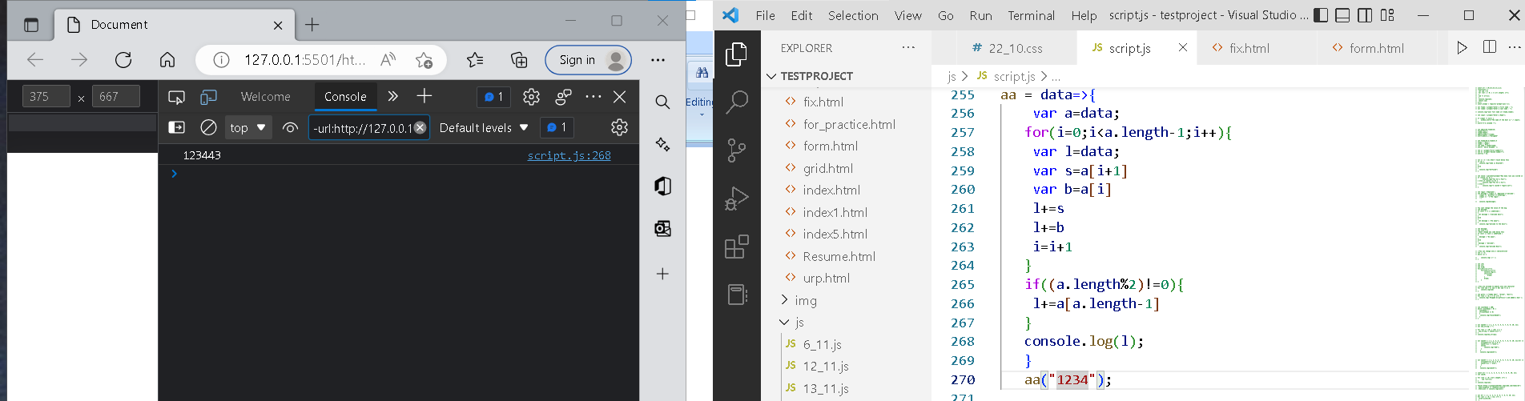

**Code:-**

aa = (f,s,t) => {

    //let f,s,t;

    console.log(f,s,t);

    if(f>s &&f>t){

    console.log(f)}

    else if(s>f && s>t){

    console.log(s)}

    else{

    console.log(t)}

   }

   aa(1,2,3);

**Output:-**

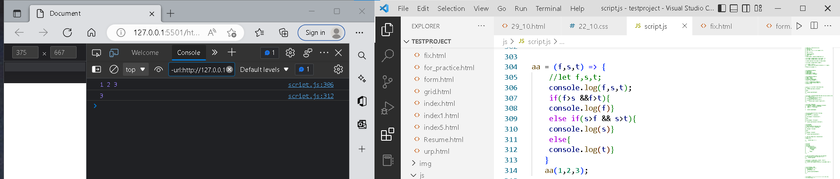

**Fix errors:-**

let n = 123;console.log(add(n));function add(n)  
{  
let sum = 10;  
for(var i=0;i<n.length;i++){  
 sum+=n[i]  
 }  
 return sum;  
}

**Output:-**

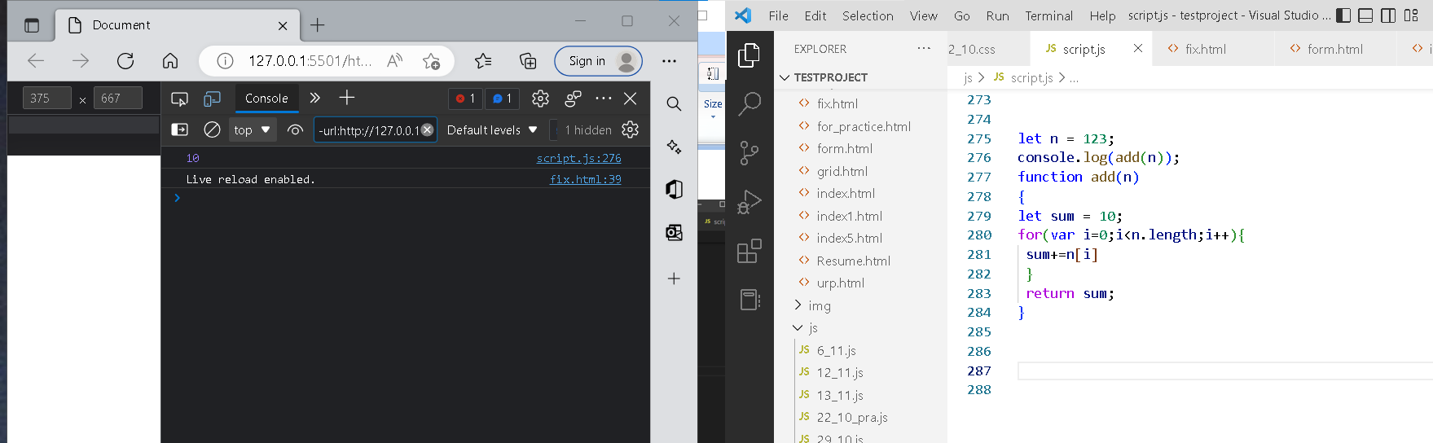

**Code:-**

let sum = 0;

 for (var i = 0; i <= arr.length; i++){

 sum += arr[i];

 }

 console.log(sum);

 return sum;

})(arr);

**Output:-**

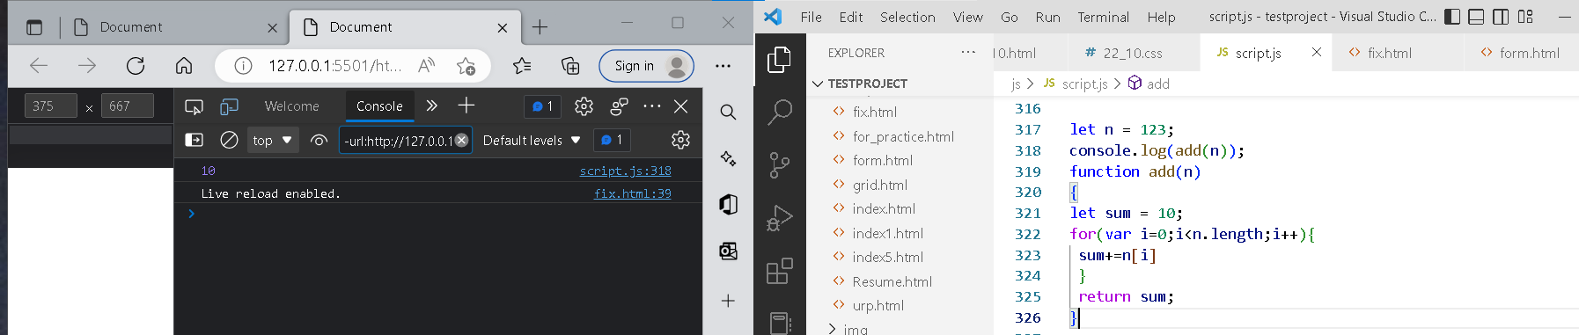

**Fix the code to Sum of the digits present in the number**

Code:

let n = 123;console.log(add(n));function add(n)  
{  
let sum = 10;  
for(var i=0;i<n.length;i++){  
 sum+=n[i]  
 }  
 return sum;  
}

**Output:-**



**Fix the code to Sum of all numbers using IIFE function**

Code:

const arr = [9,8,5,6,4,3,2,1];

(function() {  
 let sum = 0;  
 for (var i = 0; i < arr.length; i++);{  
 sum += arr[i];  
 }  
 console.log(sum);  
 return sum;  
})();

**Output:-**

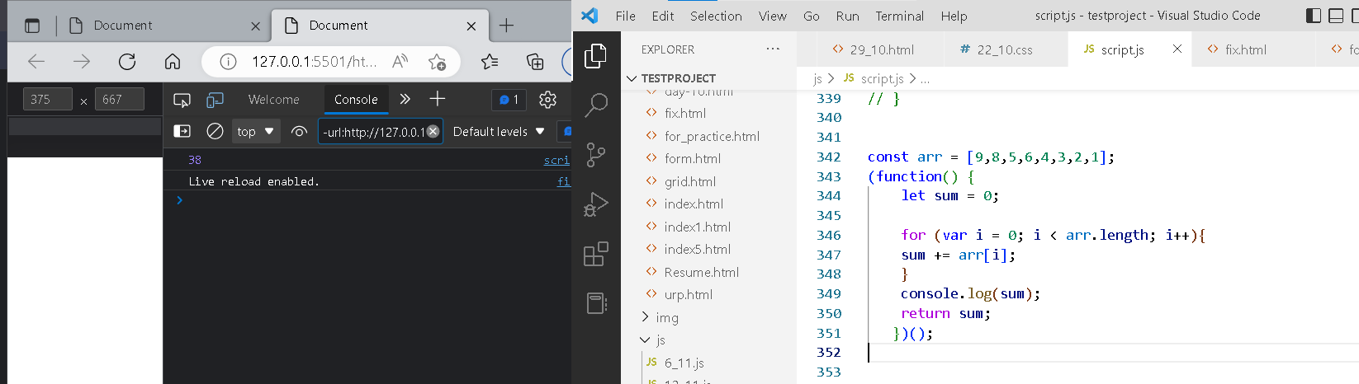

**Fix the code to gen Title caps.**

Code:

var arr = [“guvi”, “geek”, “zen”, “fullstack”];var ano = function(arro) {  
 for (var i = 0; i <= arro.length; i++) {  
 console.log(arro[i][0].toUpperCase() + arro[i].substr(1));  
 }  
}  
ano();

**Output:-**

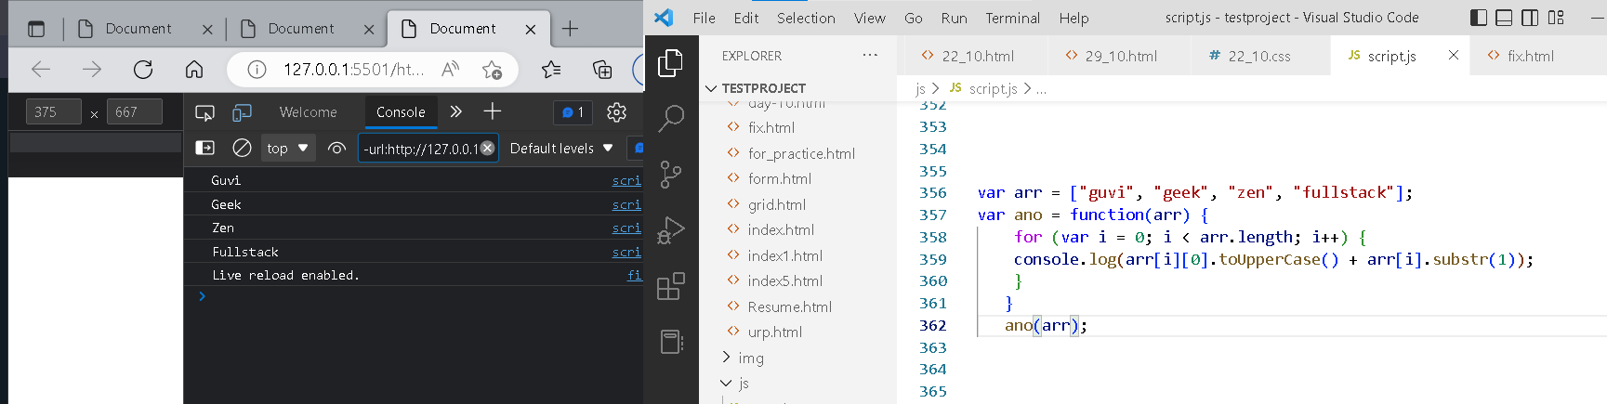

**Fix the code to return the Prime numbers**

Code:

const newArray=[1,3,2,5,10];  
const myPrime=newArray.filter(num=>{  
 for(let i=2;i<=num;i++){  
 if(num%i===0)  
 {  
 return true;  
 }  
 }  
 return num===1;  
});  
console.log(myPrime);

**Output:-**

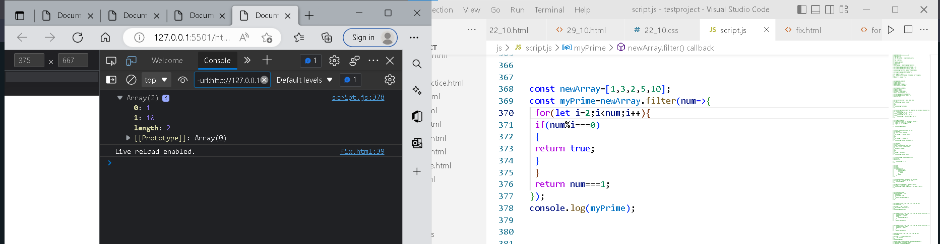

**Fix the code to sum the number in that array**

Code:

const num = [10, 20, 30, 40,50,60,70,80,90,100]   
const sum = (a, b) =>  
 a + b  
const sum = num.reduce(sum)  
console.log(sum);

**Output :-**

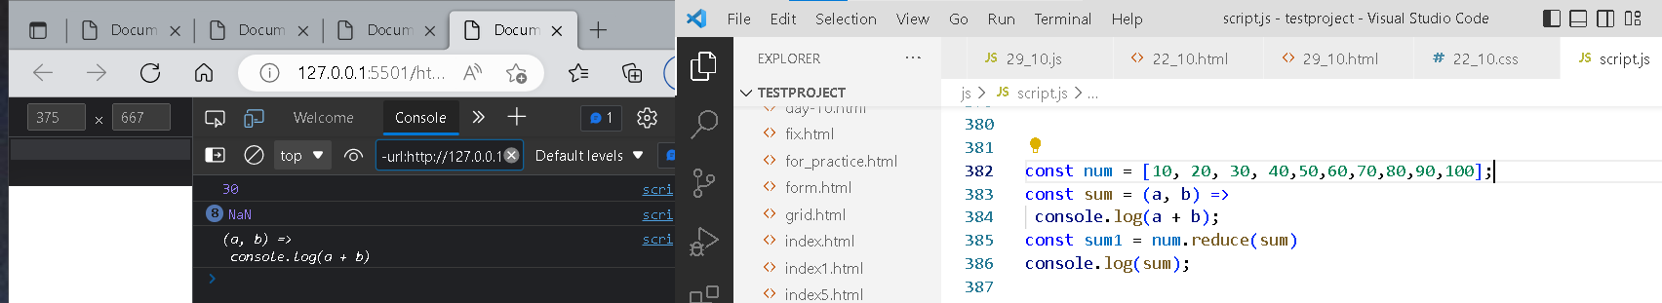

**Fix the code to rotate an array by k times and return rotated array using IIFE function**

Code:

var arr = [1, 2, 3, 6, 8, 6, 1, 9, 10, 12, 13];  
var k = 3;  
k = arr.length % k;  
(function() {  
 arr = {};  
 out = arr.slice(k + 1, arr.length);  
 var count = out.length;  
 for (var i = 0; i < k + 1; i++) {  
 out[count] = arr[i];  
 count += 1;  
 }  
 console.log(out);})();

**output:-**

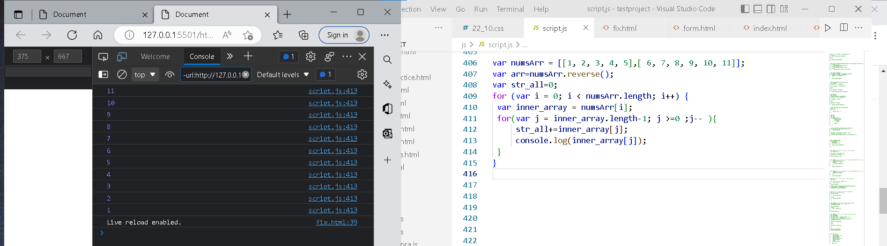

**Fix the code to reverse.**

Code:

(function(str){  
 str1 = str.split(“ “).reverse().join(“”);  
 console.log(str1);   
})(“abcd”)

**Output:-**

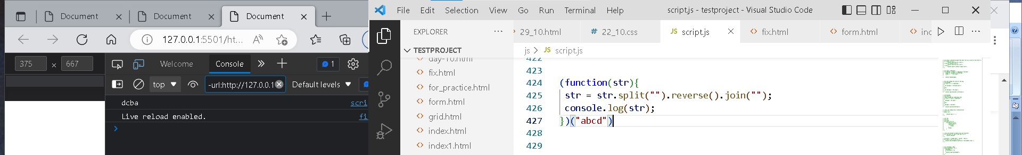

**Fix the code to remove duplicates.**

Code:

var res = function(arr){  
 for(var i=0; i < arr.length; i++){  
 newArr = [];  
 if(newArr.indexOf(arr[i]) == -1) {  
 newArr.push(arr[i]);  
 } }  
 console.log(newArr)  
}res([“guvi”,”geek”,”guvi”,”duplicate”,”geeK”])

— — — — — — — — — — — — — — — — — — — — — — — — —

**Fix the code to give the below output:**

Expected Output:

[  
{firstName: “Vasanth”, lastName: “Raja”, age: 24, role: “JSWizard”},  
{firstName: “Sri”, lastName: “Devi”, age: 28, role: “Coder”}  
]

Code:

var array =[[[“firstname”,”vasanth”],[“lastname”,”Raje”],[“age”,24],[“role”,”JSWizard”]],[[“firstname”,”Sri”],[“lastname”,”Devi”],[“age”,28],[“role”, “Coder”]]];  
var final=[]  
while(array.length!=0)  
{  
 var outer_remove = array.shift();  
   
 while(outer_remove.length!=0)  
 {  
 var inner_remove = outer_remove.shift()  
 var key = inner_remove[0]  
 var value =inner_remove[1]  
 new_object[key]=value  
 }  
 final.push(new_object)}

— — — — — — — — — — — — — — — — — — — — — — — — —

**Fix the code to give the below output:**

Sum of odd numbers in an array

Code:

var as=[12,34,5,6,2,56,6,2,1];  
var s=as.reduce(function(a,c){  
 if(c%2!=0)  
 {  
 return a+c;  
 }  
 return a;});  
console.log(s);

**—Output:-**

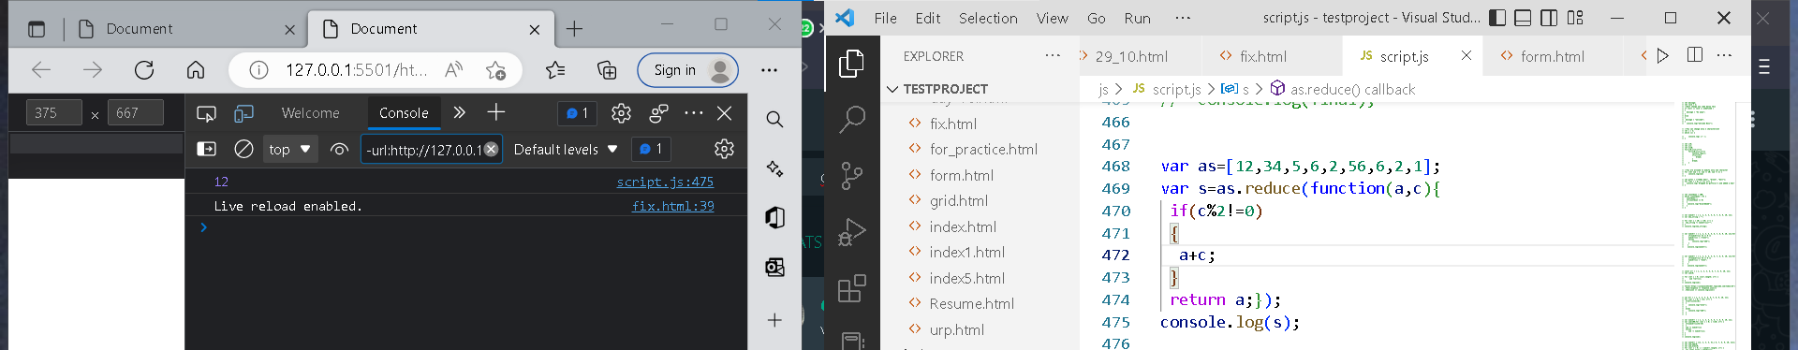

**Fix the code to give the below output:**

Swap the odd and even digits

Code:

aa = data=>{  
 var a=data;  
for(i=0;i<a.length-1;i++){  
 var l=’’;  
 var s=a[i+1]  
 var b=a[i]  
 l+=s  
 l+=b  
 i=i+1  
}  
if((a.length%2)!=0){  
 l+=a[a.length-1]  
}  
console.log(l);  
}aa(“1234”);

**output:-**

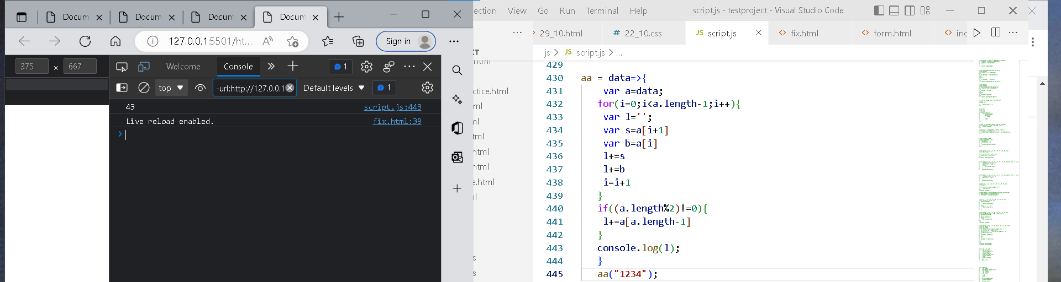

**Fix the code to give the below output:**

Expected Output:

[  
{firstName: “Vasanth”, lastName: “Raja”, age: 24, role: “JSWizard”},  
{firstName: “Sri”, lastName: “Devi”, age: 28, role: “Coder”}  
]

Code:

var array =[[[“firstname”,”vasanth”],[“lastname”,”Raje”],[“age”,24],[“role”,”JSWizard”]],[[“firstname”,”Sri”],[“lastname”,”Devi”],[“age”,28],[“role”, “Coder”]]];  
var final=[]  
while(array.length!=0)  
{  
 var outer_remove = array.shift();  
   
 while(outer_remove.length!=0)  
 {  
 var inner_remove = outer_remove.shift()  
 var key = inner_remove[0]  
 var value =inner_remove[1]  
 new_object[key]=value  
 }  
 final.push(new_object)

}